Contents

Reference link 3

Module 3 4

Agile principles and manifesto 4

Agile Value 4

Agile Principles 6

Agile Manifesto 11

four Agile Manifesto values 11

9 Principles Agile Project Manager/Project owner 13

Vision and Principles of Agile Methods 13

Summary 14

Module 4 14

Agile Methodologies 14

Overview of SCRUM Methodology 18

Different Roles in Scrum 19

Events in Scrum 20

Scrum Artifacts 20

Benefits of Scrum Methodology 21

Events in Scrum 21

Scrum Rules 22

Practicing scrum 22

Extreme Programming (XP) 22

Phases in XP 26

Roles in XP 26

XP Values 27

XP Principles 27

Advantages an disadvantages of XP 28

Test-Driven Development (TDD) 29

Phases of TDD 30

How TDD fits into Agile development 31

Benefits of Test-Driven Development (TDD) 31

Summary 31

Module 5 32

Agile Requirements 32

Requirements Management 33

Effort Estimation 34

Effort Estimation 36

Stages of Agile Estimation 37

Story Points 37

What are the Best Methods for Estimation of Software Projects? 38

Steps to Successful Story Point Estimation in Agile 42

What is Sprint Velocity? 44

How to Estimate Sprint Velocity 44

Summary 44

Module 6 45

Release Planning in Agile 45

Characteristics of Agile Planning 46

Agile Release Planning 48

Agile Release Planning 52

What is Agile release planning? 53

Purpose of Agile release planning 53

Steps to implement Agile release planning 54

Summary 54

# Reference link

Module 3

<https://www.productboard.com/glossary/agile-values/>

<https://www.wrike.com/agile-guide/agile-manifesto/>

Module 4

<https://www.digite.com/agile/test-driven-development-tdd/>

Module 5

<https://www.netsolutions.com/insights/how-to-estimate-projects-in-agile/#steps-to-successful-story-point-estimation-in-agile>

Module 6

<https://digital.ai/glossary/agile-development-success>

<https://monday.com/blog/rnd/agile-release-planning/#:~:text=The%20purpose%20of%20release%20planning,logical%20releases%20are%20frequently%20happening>.

# Module 2

## Basics of Agile Software Development

### Iterative & Incremental Approaches

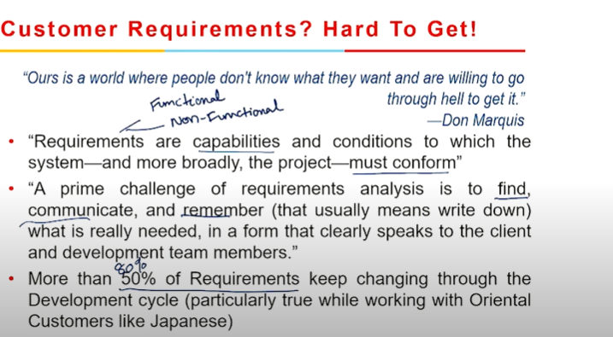

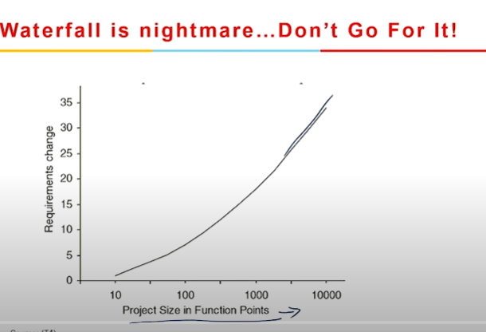





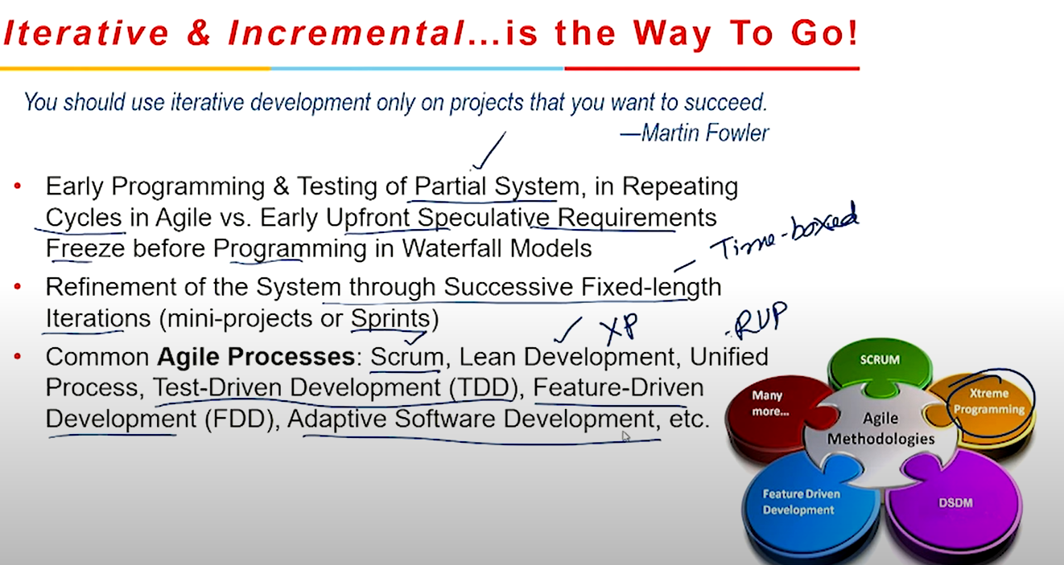

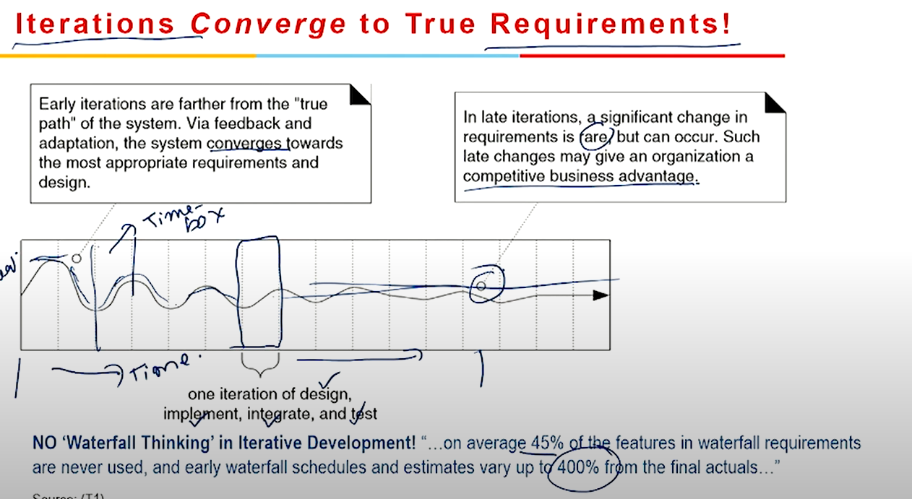





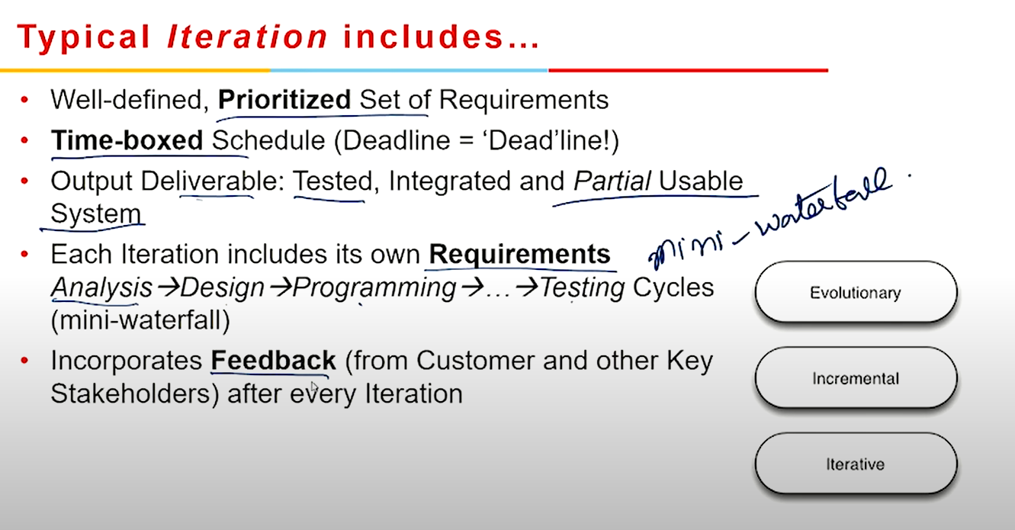

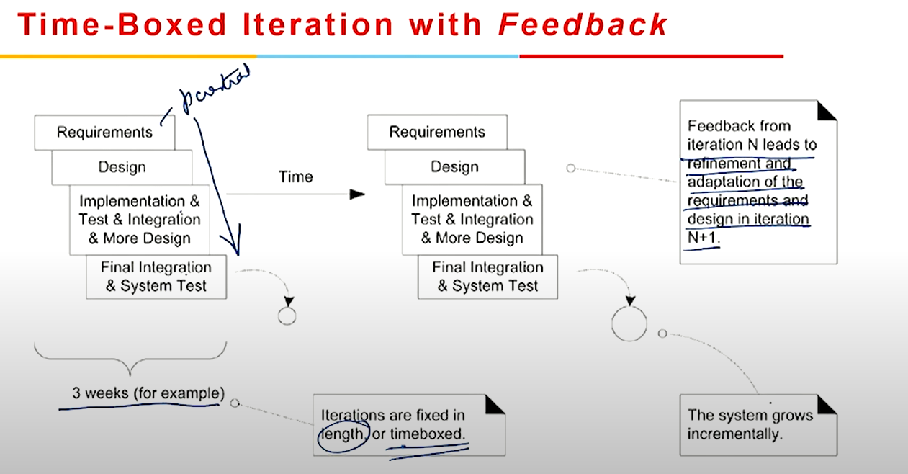

### Notes

Incremental development is a method of product development that splits the product into completely functional pieces called increments whereas Iterative development is when a team gradually adds features and functionalities but does not wait until each one is finished before releasing it.

# Module 3

## Agile principles and manifesto

### Agile Value

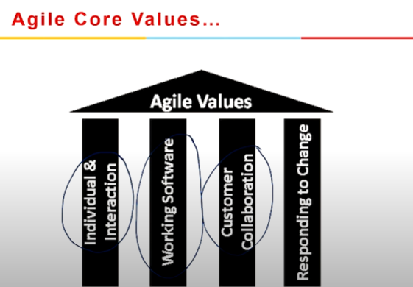

Value 1: Individuals and interactions

In the past, a lot of software teams would concentrate on having the best possible tools or processes with which to build their software. The Agile Manifesto suggests that while those things are important, the people behind the processes are even more so.

Having the right group of individuals on your software team is vital to success. The best possible tools in the wrong hands are worthless. Perhaps even more important is how these individuals communicate with each other. The interactions between team members are what helps them to collaborate and solve any problems that arise.

Value 2: Working software

Previously, software developers would spend ages creating detailed documentation. That was before they even started writing a single line of code. And while documentation isn’t a bad thing, there comes a point when you should focus on providing your customers with working software.

The Agile Manifesto places shipping software to your customers as one of the highest priorities. You can then gather feedback to help you improve future releases.

Value 3: Customer collaboration

Once upon a time, contracts were king. You would draw up contracts with your customers who would then detail the finished product. As a result, there was often a contrast between what the contract said, what the product did, and what the customer actually required.

According to the Agile Manifesto, the focus should be on continuous development. You need to build a feedback loop with your customers so that you can constantly ensure that your product works for them.

Value 4: Responding to change

Can you imagine a time where you would draw up a roadmap and it would never change? Well, in the past that’s exactly what happened.

The trouble with static roadmaps is that we don’t live in a static world. Needs and requirements are always shifting, and priorities are always changing. That static roadmap will soon grow outdated.

That’s why the Agile Manifesto suggests that a software team should have the ability to pivot and change direction whenever they need to, with a flexible roadmap that reflects that. A dynamic roadmap can change from quarter to quarter, sometimes even month to month, and agile teams are able to keep up with those changes.

### Agile Principles



It all began back in 2001 with the Agile Manifesto. There was a need for a new approach that can help organizations be more flexible, responsive, and adaptive to changes.  
Frustrated with how things were, Agile's "founding fathers" came up with a manifesto based on 12 principles.

1. Satisfy Customers Through Early & Continuous Delivery

The original formulation of the first of the Agile principles says, *"***our highest priority is to satisfy the customer through early and continuous delivery of valuable software***"*. However, it is perfectly applicable in areas outside of software development.

As you can see, customer satisfaction sits on top of the 12 principles. Early and continuous delivery increases the likelihood of meeting customer's demands and contributes to the generation of faster ROI.

By applying this concept, you will increase your process's agility and respond to changes in a timely fashion. On the other hand, your customers will be happier because they will get the value they are paying for more frequently. Also, they will be able to provide you with feedback early on, so you will be able to decrease the likelihood of making significant changes later in the process.

1. Welcome Changing Requirements Even Late in the Project

Still, if need be, change requests should be most welcome even at the late stages of project execution. The original text of the second of the Agile principles states that your team needs to **"welcome changing requirements, even late in development. Agile processes harness change for the customer's competitive advantage"***.*

In traditional project management, any late-stage changes are taken with a grain of salt as this usually means scope creep and thus higher costs. In Agile, however, teams aim to embrace uncertainty and acknowledge that even a late change can still bear a lot of value to the end customer. Due to the nature of Agile's iterative process, teams shouldn't have a problem responding to those changes in a timely fashion

1. Deliver Value Frequently

The third Agile project management principle originally states,**"deliver working software frequently, from a couple of weeks to a couple of months, with a preference to the shorter timescale"**. Its prime goal is to reduce the batch sizes that you use to process work.

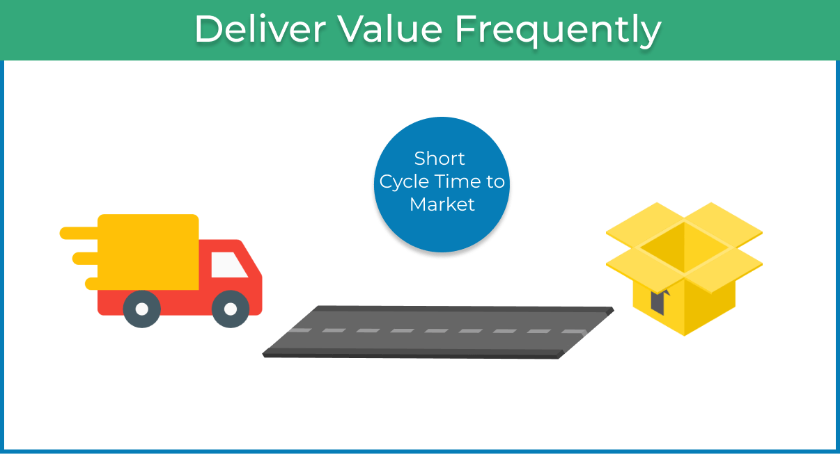

This principle became necessary due to the extensive amounts of documentation that were part of the planning process in software development at the end of the 20th century. Logically, by taking it to heart, you will reduce the time frame for which you are planning and spend more time working on your projects. In other words, your team will be able to [plan in a more agile way](https://kanbanize.com/agile/project-management/planning).

1. Break the Silos of Your Project

Agile relies on cross-functional teams to make communication easier between the different stakeholders in the project. As the original text states,**"business people and developers must work together daily throughout the project".**

In a knowledge work context that is not explicitly related to software development, you can easily change the word "developers" to "engineers" or "designers" or whatever best suits your situation. The goal is to create a synchronization between the people who create value and those who plan or sell it. This way, you can make internal collaboration seamless and improve your process performance.

1. Build Projects Around Motivated Individuals

The logic behind the fifth of the Agile principles is that by reducing micromanagement and empowering motivated team members, projects will be completed faster and with better quality.

Like the original text following the Agile manifesto states, you need to "**build projects around motivated individuals. Give them the environment and support they need, and trust them to get the job done".**

The second sentence of this principle is especially important. If you don't trust your team and keep even the tiniest decisions in your company centralized, you will only hinder your team's engagement. As a result, individuals will never feel a sense of belonging to the purpose that a given project is trying to fulfill, and you won't get the most of their potential.

1. The Most Effective Way of Communication is Face-to-face

**"The most efficient and effective method of conveying information to and within a development team is face-to-face conversation."**

In 2001, this principle was spot on. By communicating in person, you reduce the time between asking a question and receiving an answer. However, in the modern work environment where teams collaborate across the globe, it provides a severe limitation.

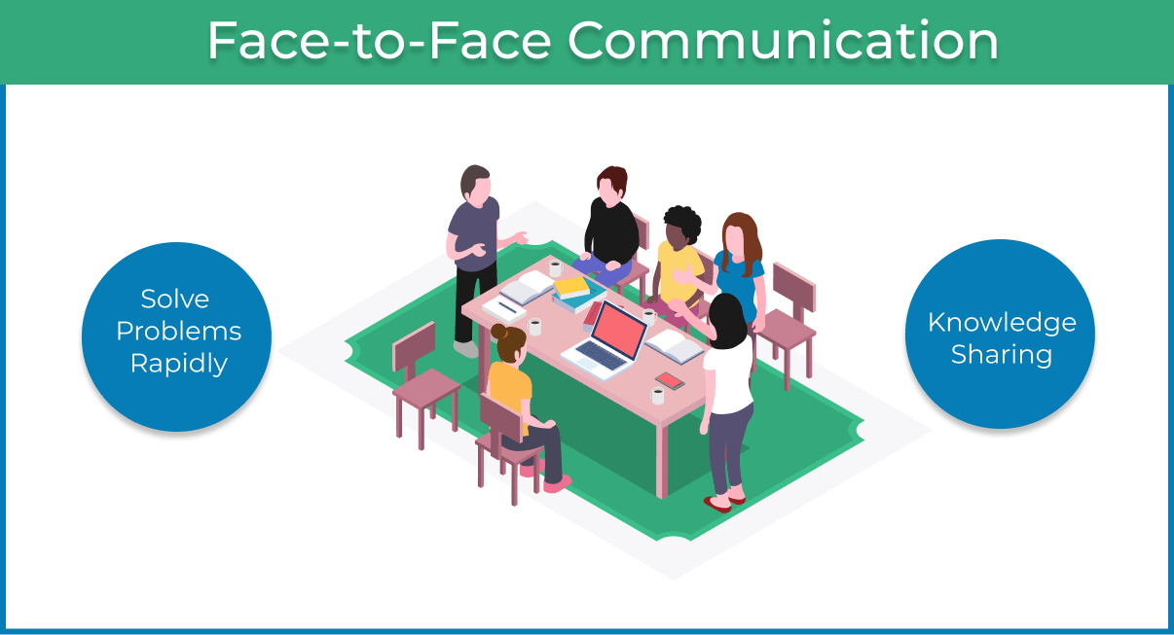

Thankfully, with the development of technology, you can interpret this Agile principle from face-to-face to "synchronous" or otherwise direct communication. So as long as you have a way to quickly reach your team and discuss work matters without bouncing back and forward emails for days, you are good to go.

1. Working Software is the Primary Measure of Progress

The 7th of the Agile core principles is pretty straight forward. It doesn't matter how many working hours you've invested in your project, how many bugs you managed to fix, or how many lines of code your team has written.

If the result of your work is not the way your customer expects it to be, you are in trouble

1. Maintain a Sustainable Working Pace

The precise formulation of this principle is **"Agile processes promote sustainable development. The sponsors, developers, and users should be able to maintain a constant pace indefinitely."**

Logically, when putting Agile to practice, your goal is to avoid overburden and optimize the way you work so you can frequently deliver to the market and respond to change without requiring personal heroics from your team.

1. Continuous Excellence Enhances Agility

As stated by the Agile Manifesto founders, **"continuous attention to technical excellence and good design enhances agility"**. In a development context, this principle allows teams to create not just working software but also a stable product of high quality.

As a result, changes to the code will be less likely to impact bugs and malfunctions negatively.

Still, the 9th of the Agile management principles is applicable in every industry. When you maintain operational excellence, you will have less trouble reacting to changes and maintaining agility.

1. Simplicity is Essential

This principle's original content can be a bit confusing as it states, **"Simplicity–the art of maximizing the amount of work not done–is essential"**. Yet, it is very practical.

If you can do something in a simple way, why waste time complicating it? Your customers are not paying for the amount of effort you invest. They are buying a solution to a specific problem that they have. Keep that in mind, when [implementing Agile](https://kanbanize.com/agile/project-management/agile-implementation) and avoid doing something just for the sake of doing it.

1. Self-organizing Teams Generate Most Value

Once again, we realize that when provided with freedom, motivated teams generate the most value for the customer. When discussing this principle, the 17 fathers of Agile stated that**"the best architectures, requirements, and designs emerge from self-organizing teams".**

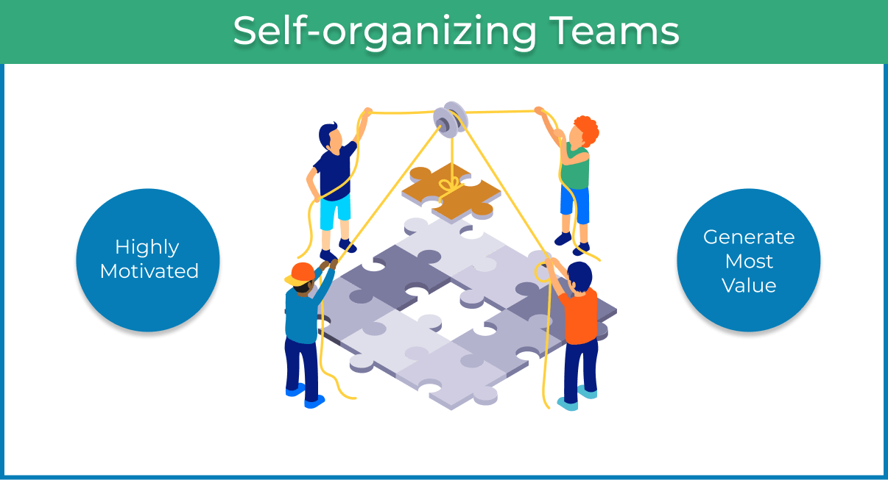

If you have to push your team and "drive them forward", maybe you are not ready for Agile, or you need to make some changes to your leading style.

1. Regularly Reflect and Adjust Your Way of Work to Boost Effectiveness

Finally, we've come to the last of the Agile management principles. It is related to evaluating your performance and identifying room for improvement. The long version of the principle states: **"At regular intervals, the team reflects on how to become more effective, then tunes and adjusts its behavior accordingly"**.

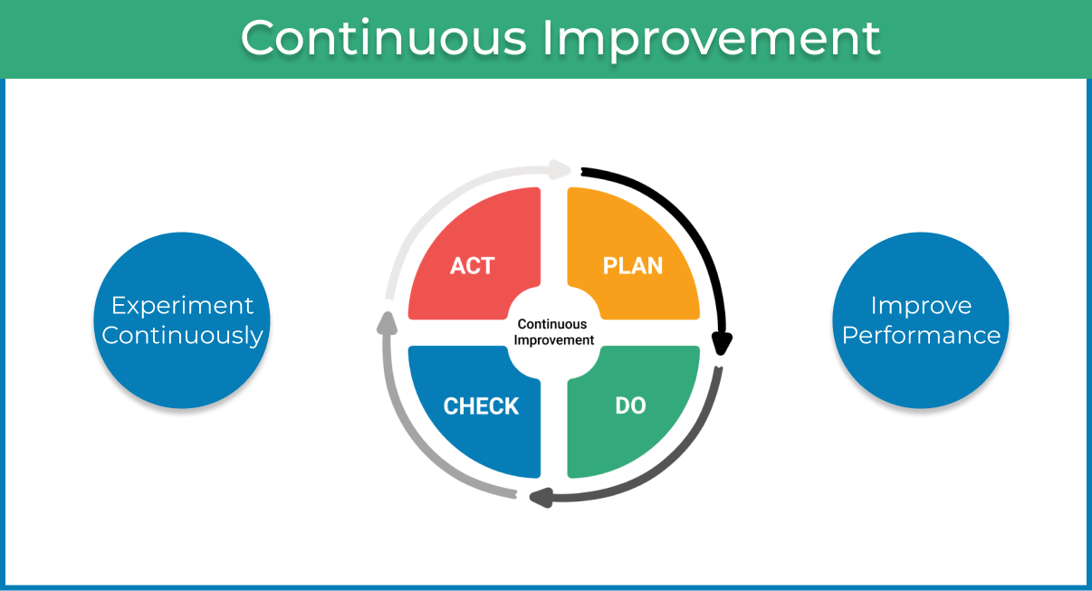

By doing this, you will be able to experiment and improve your performance continuously. If things don't go as you've planned, you can discuss what went wrong and adjust to get back on track.

There are different Agile methods, but Agile itself is not a methodology or a framework. It is a set of values and principles. This is why it is incredibly flexible and can be applied by different organizations. However, to make a successful transformation, you need to have the necessary foundation. Implementing the 12 Agile principles is precisely how you build it.

### Agile Manifesto



The Agile Manifesto is a document that outlines the central values and principles of Agile software development. Officially referred to as the Manifesto for Agile Software Development, the guide aims to provide an effective model for teams to successfully adopt the philosophy of Agile project management and use it to improve their work process.

The lightweight framework of the Agile Manifesto was designed to improve upon existing software development processes, which were more complex and contained a lot of documentation. The founders wanted to speed up these processes and create a more efficient working model for teams.

Put simply, the Agile Manifesto is an alternative to traditional software development methodologies

### four Agile Manifesto values

The Agile Manifesto was founded on four key values, which are as follows:

**1. Individuals and interactions over processes and tools**

The first value gets straight to the core of Agile methodology: the focus is on the people. You can use the best processes and tools available to support your projects, but they will only work if your people are doing their best work. Your team is your most valuable resource. Communication plays a key role here — when people interact with each other regularly and share their ideas, they build better products.

Jim Highsmith, one of the authors of the Agile Manifesto, wrote about the importance of the “mushy stuff,” meaning prioritizing people over processes. Rather than simply proclaiming that people are the most important factor, he advises that software developers actually act as if people are the most important factor.

**2. Working software over comprehensive documentation**

Before Agile practices were fully implemented, teams would spend hours creating exhaustive documents with technical specifications, requirements, and more. These lists would be prepared before developers started to write the code, meaning the whole process was delayed as the documentation took so long to compile.

The Agile philosophy is to streamline these documents and condense the information into user stories. These stories equip the developer with all the details they need to start working on the software and get it ready for release. The idea is to accelerate the launch process and make product tweaks in the early stages, improving the software in future iterations.

**3. Customer collaboration over contract negotiation**

The third value of the Agile Manifesto highlights the importance of customer collaboration. This is viewed as superior to contract negotiation, which involves outlining product requirements with the customer before commencing the project and then renegotiating these deliverables at a later stage. The issue here is that the customer is not engaged throughout the development cycle, so teams lose out on user feedback that could enhance the product.

When you bring your customers into the development process, you can ask for their opinions regularly and take their suggestions on board. By delving into their specific needs while the software is still being built, developers can gain valuable insights to create the ultimate user experience.

**4. Responding to change over following a plan**

Traditional methodologies advocated for as little change as possible, recognizing that significant alterations could cost time and money. The aim was to create a comprehensive plan that followed a structured, linear path and avoided obstacles where possible.

The Agile mentality turns this rigid method on its head, arguing that change can benefit the software development process. When you embrace change, you open yourself up to new possibilities and ways to improve. Agile teams work in short, iterative cycles, meaning they can react quickly and implement changes on a continuous basis. This ultimately leads to better products.

These four values form the basis of Agile software development, highlighting key priority areas for teams to focus their energies on. The core values are supported by the 12 Agile Manifesto principles.

### 9 Principles Agile Project Manager/Project owner



### Vision and Principles of Agile Methods

The Agile Manifesto is a document that identifies four key values and 12 principles that its authors believe software developers should use to guide their work.

1. Customer satisfaction through continuous delivery of the product
2. Divide large chunks of work into smaller, more manageable jobs to speed up completion and make change integration easier.
3. Meet the agreed-upon timeline for delivering a functional product.
4. To guarantee that the project is moving in the right direction, all stakeholders must work together regularly.
5. Encourage team members to get the task done by creating a supportive environment.
6. Prefer face-to-face communication over other methods
7. The major indicator of progress is working software.
8. Try to maintain a constant pace of development.
9. Maintain quality of the product by paying attention to technical details.
10. Keep things simple.
11. Encourage team members to organize themselves.
12. Evaluate your performance regularly to improve

## Summary

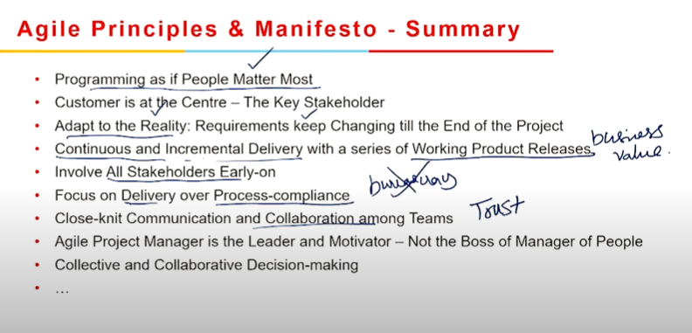

# Module 4

## Agile Methodologies

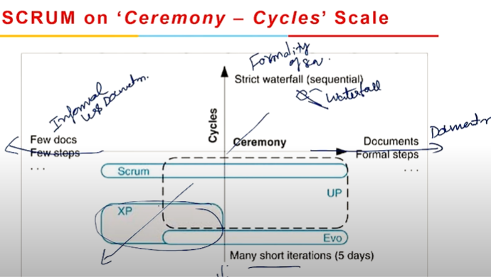

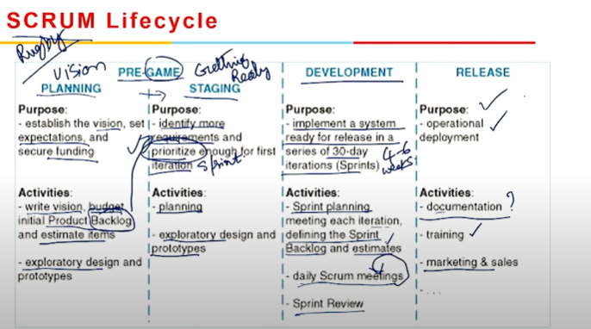

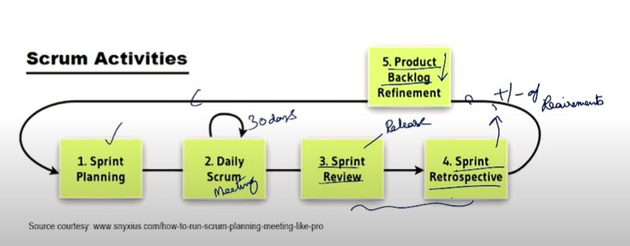

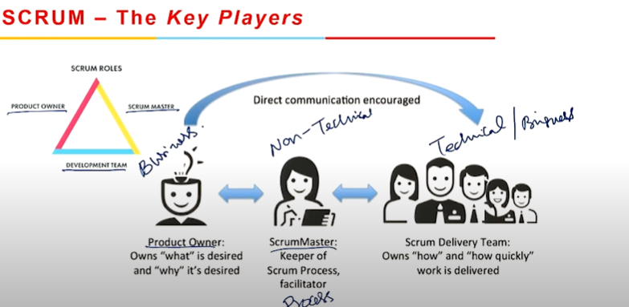

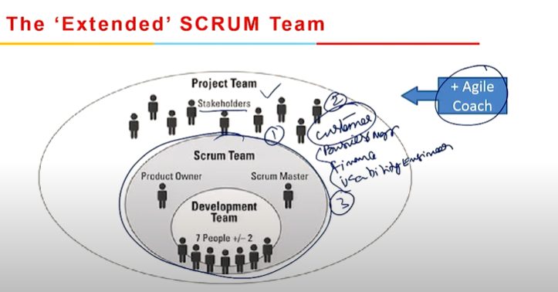

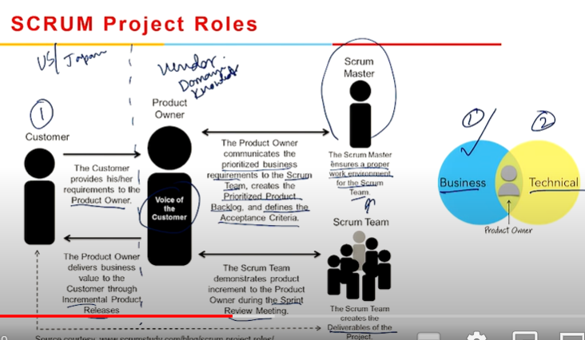

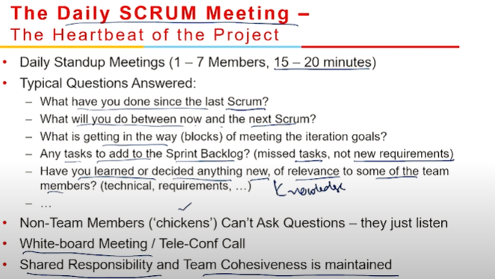

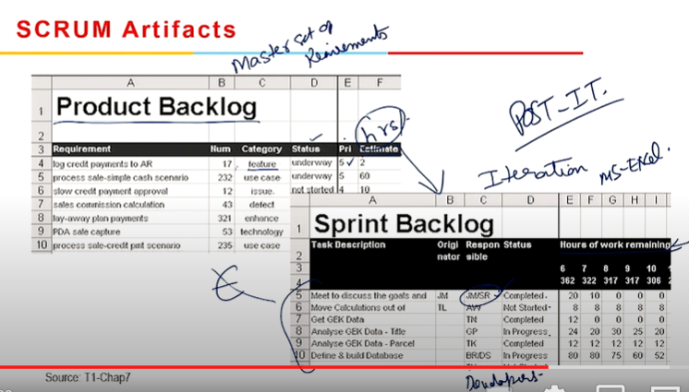

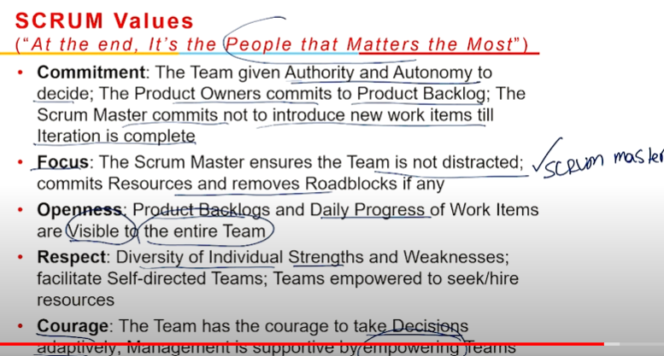

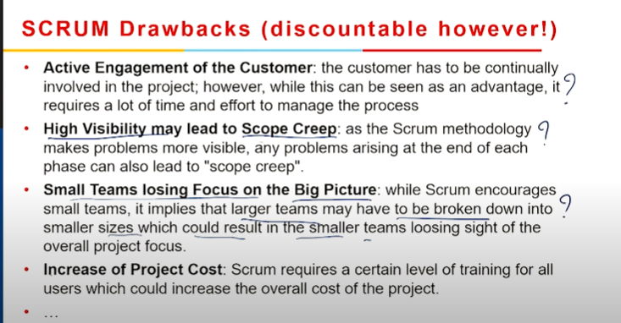

### Overview of SCRUM Methodology

Scrum is a framework for facilitating teamwork. Scrum encourages teams to learn from experiences, self-organize while working on an issue, and reflect on their successes and failures to continuously improve, much like a rugby team (from which it gets its name).

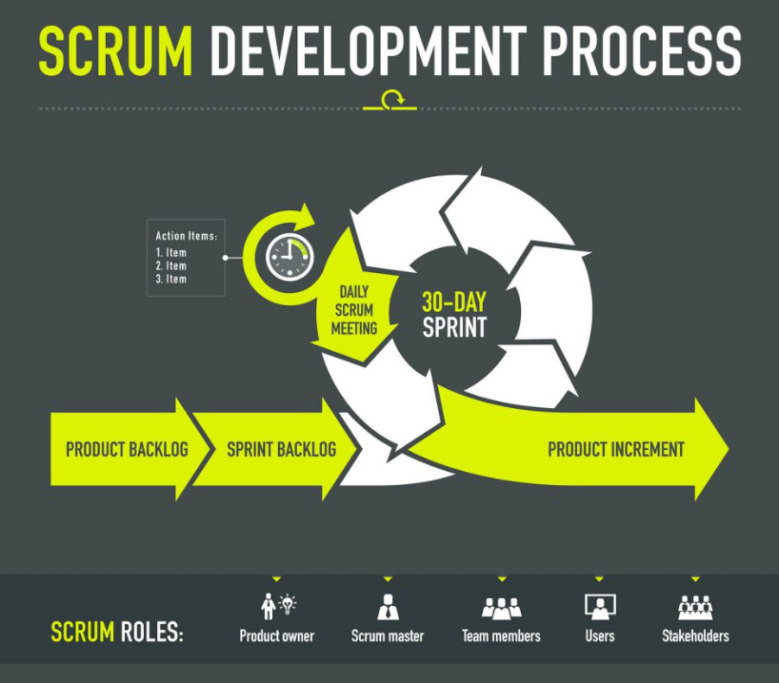

### Different Roles in Scrum

In Scrum, the team focuses on building quality software. The owner of a Scrum project focuses on defining what are the characteristics that the product must have to build (what to build, what not and in what order) and to overcome any obstacle that could hinder the task of the development team.

The Scrum team consists of the following roles:

**Scrum master**: The person who leads the team guiding them to comply with the rules and processes of the methodology. Scrum master manages the reduction of impediments of the project and works with the Product Owner to maximize the ROI. The Scrum Master is in charge of keeping Scrum up to date, providing coaching, mentoring and training to the teams in case it needs it.

**Product owner (PO):** Is the representative of the stakeholders and customers who use the software. They focus on the business part and is responsible for the ROI of the project. They Translate the vision of the project to the team, validate the benefits in stories to be incorporated into the Product Backlog and prioritize them on a regular basis.

**Team**: A group of professionals with the necessary technical knowledge who develop the project jointly carrying out the stories they commit to at the start of each sprint.

### Events in Scrum

Each of the Scrum events facilitates the adaptation of some of the aspects of the process, the product, progress or relationships.

**Sprint**: Sprint is the basic unit of work for a Scrum team. This is the main feature that marks the difference between Scrum and other models for agile development.

**Sprint Planning**: The goal of the Sprint Planning is to define what is going to be done in the Sprint and how it is going to be done. This meeting is held at the beginning of each Sprint and is defined how it will approach the project coming from the Product Backlog stages and deadlines. Each Sprint is composed of different features.

**Daily Scrum**: The objective of the Daily Scrum is to evaluate the progress and trend until the end of the Sprint, synchronizing the activities and creating a plan for the next 24 hours. It is a brief meeting that takes place daily during the Sprint period. Three questions are answered individually: What did I do yesterday? What am I going to do today? What help do I need? The Scrum Master should try to solve problems or obstacles that arise.

**Sprint Review:** The goal of the sprint review is to show what work has been completed with regards to the product backlog for future deliveries. The finished sprint is reviewed, and there should already be a clear and tangible advancement in the product to present to the client.

**Sprint Retrospective:** The team reviews the completed goals of the finished sprint, write down the good and the bad, so as not to repeat the mistakes again. This stage serves to implement improvements from the point of view of the development process. The goal of the sprint retrospective is to identify possible process improvements and generate a plan to implement them in the next Sprint.

### Scrum Artifacts

Scrum Artifacts are designed to guarantee the transparency of key information in decision making.

**Product Backlog (PB):** The product backlog is a list that collects everything the product needs to satisfy the potential customers. It is prepared by the product owner and the functions are prioritized according to what is more and less important for the business. The goal is for the product owner to answer the question “What should be done”.

**Sprint Backlog (SB):** It is a subset of items of the product backlog, which are selected by the team to perform during the sprint on which they are going to work. The team establishes the duration of each Sprint. Usually the sprint backlog, is displayed on physical boards called as Scrum board – that makes the development process visible to everyone who enters the development area.

**Increment**: The Increment is the sum of all the tasks, use cases, user stories, product backlogs and any element that was developed during the sprint and that will be made available to the end user in the form of Software.

### Benefits of Scrum Methodology

Scrum has many advantages over other agile development methodologies. It is currently the most used and trusted framework of reference in the software industry. Below are some of the known benefits of Scrum:

**Easily Scalable**: Scrum processes are iterative and are handled within specific work periods, which makes it easier for the team to focus on definite functionalities for each period. This not only has the benefit of achieving better deliverables in line with the needs of the user, but also gives the ability to the teams to scale the modules in terms of functionality, design, scope and characteristics in an orderly, transparent and simple manner.

**Compliance of expectations**: The client establishes their expectations indicating the value that each requirement/ history of the project brings, the team estimates them and with this information the Product Owner establishes its priority. On a regular basis, in the sprint demos, the Product Owner verifies that the requirements have been met and transmits feedback to the team.

**Flexible to changes**: Quick reaction to changes in requirements generated by customer needs or market developments. The methodology is designed to adapt to the changing requirements that complex projects entail.

**Time to Market reduction**: The client can start using the most important functionalities of the project before the product is completely ready.

**Higher software quality**: The working method and the need to obtain a functional version after each iteration, helps to obtain a higher quality software.

**Timely Prediction**: Using this methodology, we know the average speed of the team by sprint (story points), with which, consequently, it is possible to estimate when a certain functionality that is still in the backlog will be available.

**Reduction of risks**: The fact of carrying out the most valuable functionalities in the first place and of knowing the speed with which the team advances in the project, allows to clear risks effectively in advance

### Events in Scrum

Each of the Scrum events facilitates the adaptation of some of the aspects of the process, the product, progress or relationships.

**Sprint**: Sprint is the basic unit of work for a Scrum team. This is the main feature that marks the difference between Scrum and other models for agile development.

**Sprint Planning**: The goal of the Sprint Planning is to define what is going to be done in the Sprint and how it is going to be done. This meeting is held at the beginning of each Sprint and is defined how it will approach the project coming from the Product Backlog stages and deadlines. Each Sprint is composed of different features.

**Daily Scrum**: The objective of the Daily Scrum is to evaluate the progress and trend until the end of the Sprint, synchronizing the activities and creating a plan for the next 24 hours. It is a brief meeting that takes place daily during the Sprint period. Three questions are answered individually: What did I do yesterday? What am I going to do today? What help do I need? The Scrum Master should try to solve problems or obstacles that arise.

**Sprint Review**: The goal of the sprint review is to show what work has been completed with regards to the product backlog for future deliveries. The finished sprint is reviewed, and there should already be a clear and tangible advancement in the product to present to the client.

**Sprint Retrospective**: The team reviews the completed goals of the finished sprint, write down the good and the bad, so as not to repeat the mistakes again. This stage serves to implement improvements from the point of view of the development process. The goal of the sprint retrospective is to identify possible process improvements and generate a plan to implement them in the next Sprint

### Scrum Rules

The agile scrum rules should be determined by the team and based on what works best for their processes. The best agile coaches will tell teams to start with the basic scrum events outlined above, then inspect and adapt based on your team's specific needs so that collaboration improves over time.

### Practicing scrum

To get started with scrum, it is not uncommon for an individual scrum team to manage the product backlog and the progress of sprint backlog items in each sprint using simple scrum tools such as a whiteboard, sticky notes, or a spreadsheet. Scaling agile practices to the rest of the organization is unquestionably more challenging - the more scrum teams an organization has or the more geographically dispersed they are, the more cumbersome simple tools like whiteboards, sticky notes, and spreadsheets become.

## Extreme Programming (XP)

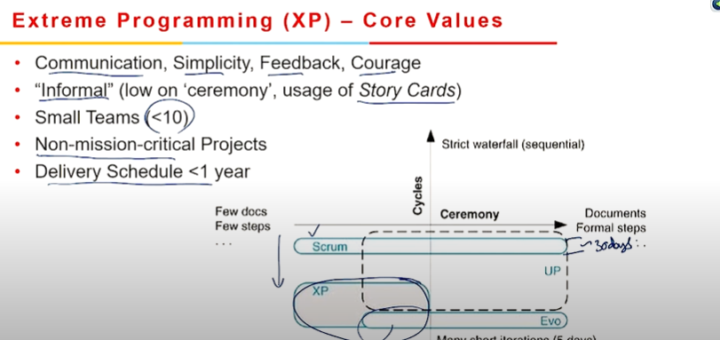

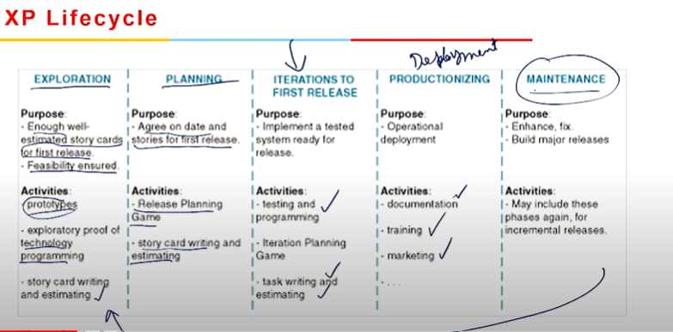

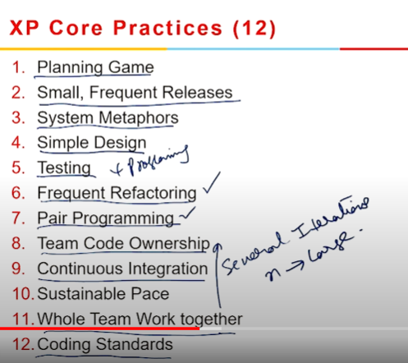

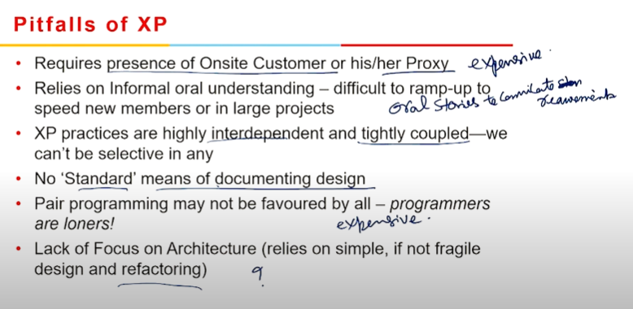

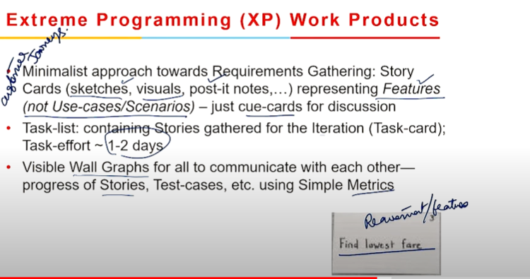

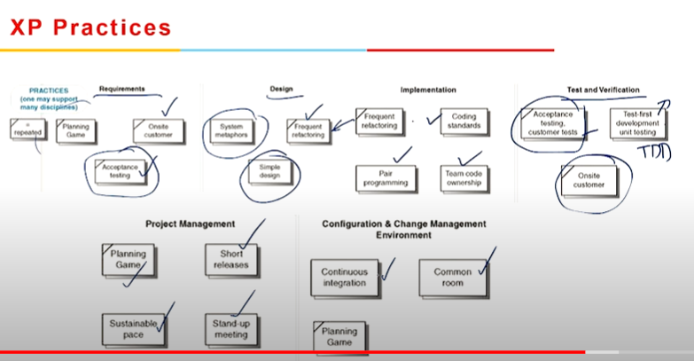

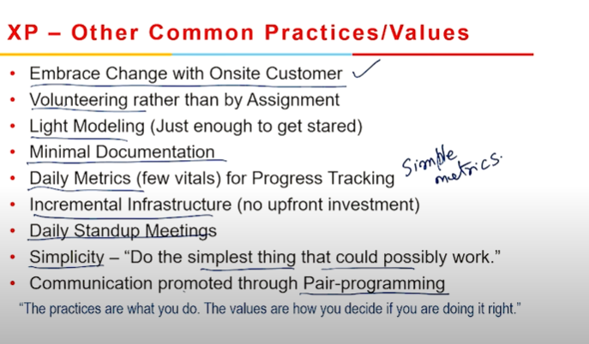

One of the many Agile frameworks used by IT companies is Extreme Programming (XP). However, XP stands out from the other methods because of its focus on technical aspects of software development.

XP is a set of engineering practices. Developers have to go beyond their capabilities while performing these practices. That’s where the “extreme” in the framework’s title comes from.

### Phases in XP

The XP framework normally involves 5 phases or stages of the development process that iterate continuously:

1. The first stage is planning, which involves the customer meeting with the development team and presenting the requirements in the form of user stories that explain the desired outcome. After that, the team estimates the stories and prepares a release plan with iterations to cover the desired features piece by piece. If one or more of the stories cannot be estimated, so-called spikes can be used to indicate the need for more research.
2. Although designing is a part of the planning process, it can be distinguished to underline its importance. It's to do with simplicity and is one of the key XP values we'll go into later. A good design gives the system logic and structure while avoiding needless complexity and redundancies.
3. Coding is the phase in which actual code is written adopting XP practices like coding standards, pair programming, continuous integration, and collective code ownership.
4. Testing is the core of extreme programming. It is a regular activity that involves both unit tests and acceptance tests.
5. It's all about continual communication and feedback when it comes to listening. Customers and project managers are involved in describing the expected business logic and value.

### Roles in XP

Extreme programming emphasizes the significance and necessity of social skills such as communication, cooperation, responsiveness, and feedback by placing people at the core of the system. As a result, these roles are commonly related to XP:

1. Customers are expected to participate actively in the development process by creating user stories, providing continuous feedback, and making all necessary business decisions.
2. Programmers, often known as developers, are the members of the team who create the product. They are responsible to carry out user tests and implementing user stories. Since XP is usually associated with cross-functional teams, members' skills may vary.
3. Trackers or managers link customers and developers. It's not a required role, and any of the developers could do it. These individuals plan the meetings, regulate discussions, and maintain track of key performance indicators (KPIs).
4. Coaches can function as mentors for the teams to help them understand the XP practices. It's usually an external assistant or consultant who isn't involved in the development process but has expertise with XP and may help avoid errors.

### XP Values

XP has simple rules that are based on 5 values to guide teamwork:

1. **Communication.** Everyone on a team works jointly at every stage of the project.
2. **Simplicity.** Developers strive to write simple code bringing more value to a product, as it saves time and effort.
3. **Feedback.** Team members deliver software frequently, get feedback about it, and improve a product according to the new requirements.
4. **Respect.** Every person assigned to a project contributes to a common goal.
5. **Courage.** Programmers objectively evaluate their results without making excuses and are always ready to respond to changes

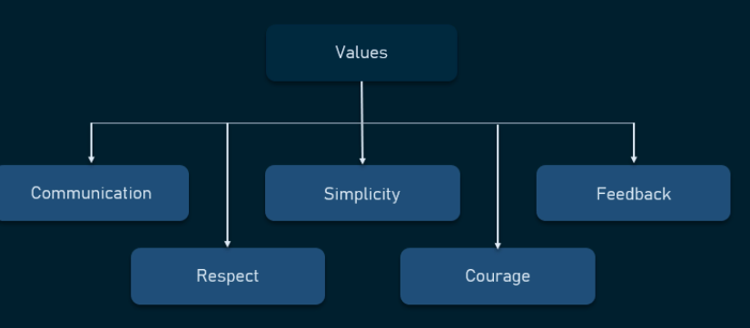

### XP Principles

Most researchers denote 5 XP principles as:

1. **Rapid feedback.** Team members understand the given feedback and react to it right away.
2. **Assumed simplicity.** Developers need to focus on the job that is important at the moment and follow YAGNI (You Ain’t Gonna Need It) and DRY (Don’t Repeat Yourself) principles.
3. **Incremental changes.** Small changes made to a product step by step work better than big ones made at once.
4. **Embracing change.** If a client thinks a product needs to be changed, programmers should support this decision and plan how to implement new requirements.
5. **Quality work.** A team that works well, makes a valuable product, the team needs to come and regularly feel developing proud save resolve team of it.

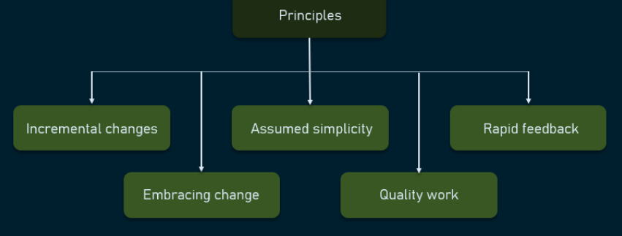

### Advantages an disadvantages of XP

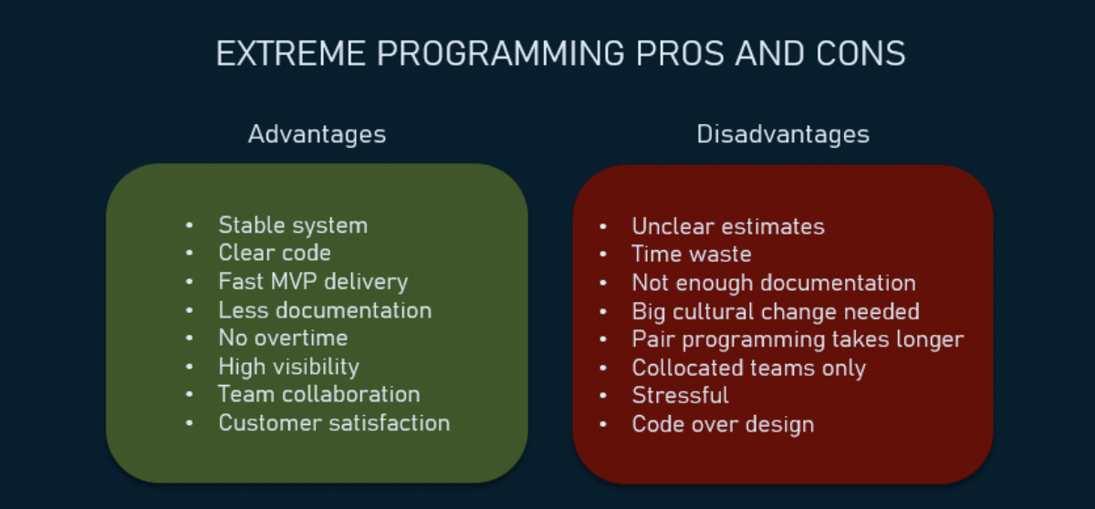

## Test-Driven Development (TDD)

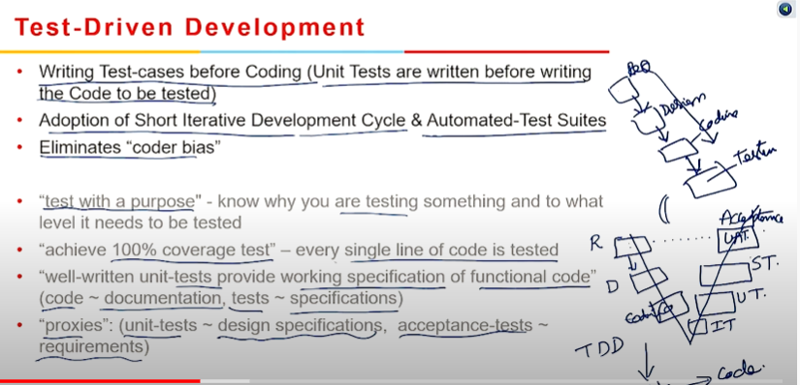





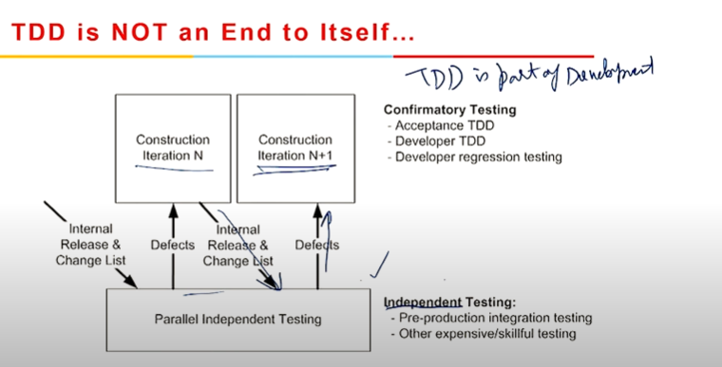

TDD is based on the Agile manifesto concepts and Extreme programming. The test process, as its name implies, is what drives software development. Moreover, it is a structuring method that allows developers and testers to obtain optimized code that is resilient in long term.

### Phases of TDD

* **Create precise tests** To validate the functionality of specific features, developers must create precise unit tests. They must confirm that the test builds before running it. In the vast majority of circumstances, the test will fail. Developers are writing compact tests based on their expectations about how the product will operate, therefore this is a significant failure.
* **Correcting the Code** Once a test fails, developers need to make the minimal changes required to correct the code so that it can run successfully when re-executed.
* **Refactor the Code** Once the test has passed, look for any redundancy or code optimizations that could improve overall performance. Ascertain that refactoring has no impact on the program's external behavior.

### How TDD fits into Agile development

Agile development demands regular feedback to develop the expected product. Agile development can also be referred to as Feedback Driven Development.

During the development sprint cycle, there's a good chance that project requirements might change. To deal with this and produce solutions that are aligned with the changing needs of clients, teams require frequent input to avoid delivering unusable software. TDD is built to provide this type of early feedback.

### Benefits of Test-Driven Development (TDD)

1. Encourages the development of optimized code.
2. Helps developers in better analyzing and understanding client requirements, as well as requesting clarify when they are not clearly defined.
3. In the later stages of development, adding and testing new capabilities becomes much easier.
4. Test coverage is much higher in TDD than that in traditional development models.

## Summary

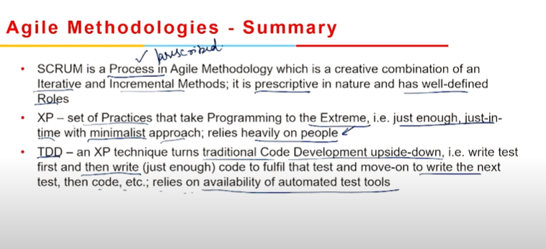

# Module 5

Agile Requirements









### Requirements Management

The primary goal of Agile, a relatively new set of principles, concepts, and frameworks, is to help development teams and companies better serve their customers' needs. Above all, any Agile development project aims to deliver working software as fast as possible, with "working" meaning a product that can successfully handle the customer's problems. To be able to deliver a solution, one must first understand what the problem is. That’s why requirements management is at the heart of any Agile project.

## Effort Estimation

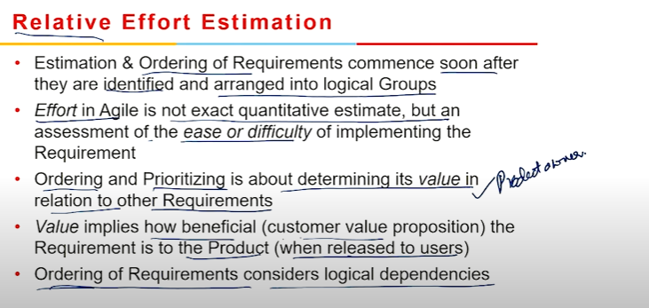

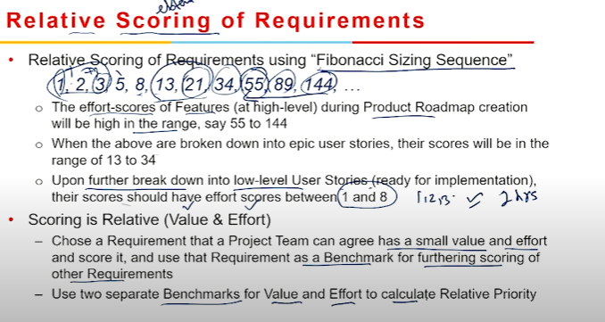

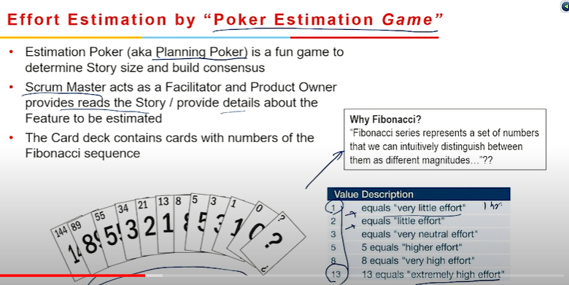



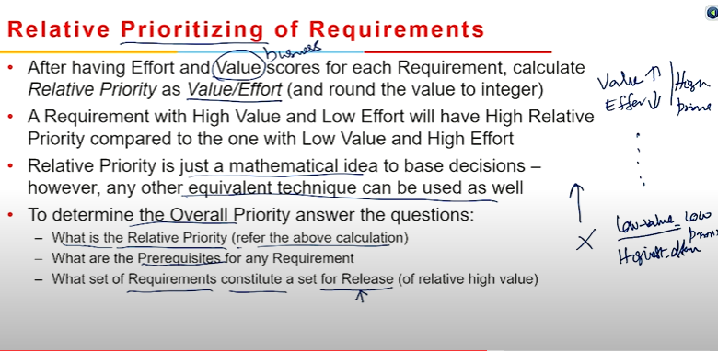

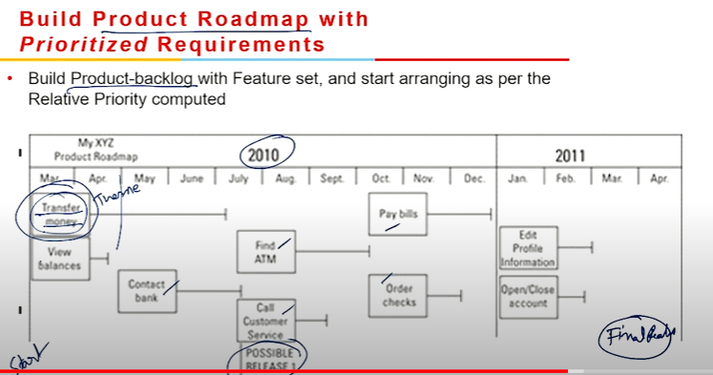

### Effort Estimation

Agile development teams are prone to both overestimating and underestimating, resulting in varied development and launch times. Considering Agile estimation in the early stages of the process can help with accurate user story estimations and keep the team on track with timely deliverables, despite the complexity of the process.

The following are some of the key benefits of Agile Estimation techniques:

1. **Improved Decision-Making** With story accurate, agile estimates the development team will be able to conduct effective backlog grooming sessions, which will benefit in precise sprint planning. Their user story delivery time will improve if they make informed decisions and plan well.
2. **Better Coordination**  
    Let's assume the effort for user story A is anticipated to be two weeks. User story B, on the other hand, requires a four-week estimation effort. Assume that both user stories are interdependent on one another. In that situation, the team must prioritize work so that both user stories are finished at the same time, resulting in better team coordination.
3. **Better Risk Management**  
    Budgets and timelines are often exceeded in software projects. Agile project estimate is an excellent way to minimize this risk. Agile product estimation helps in the estimate story points as well as the compliance to budgets, estimations, and project scope. The more precise the estimates, the more likely it is that the product will be delivered on time and in good condition

### Stages of Agile Estimation

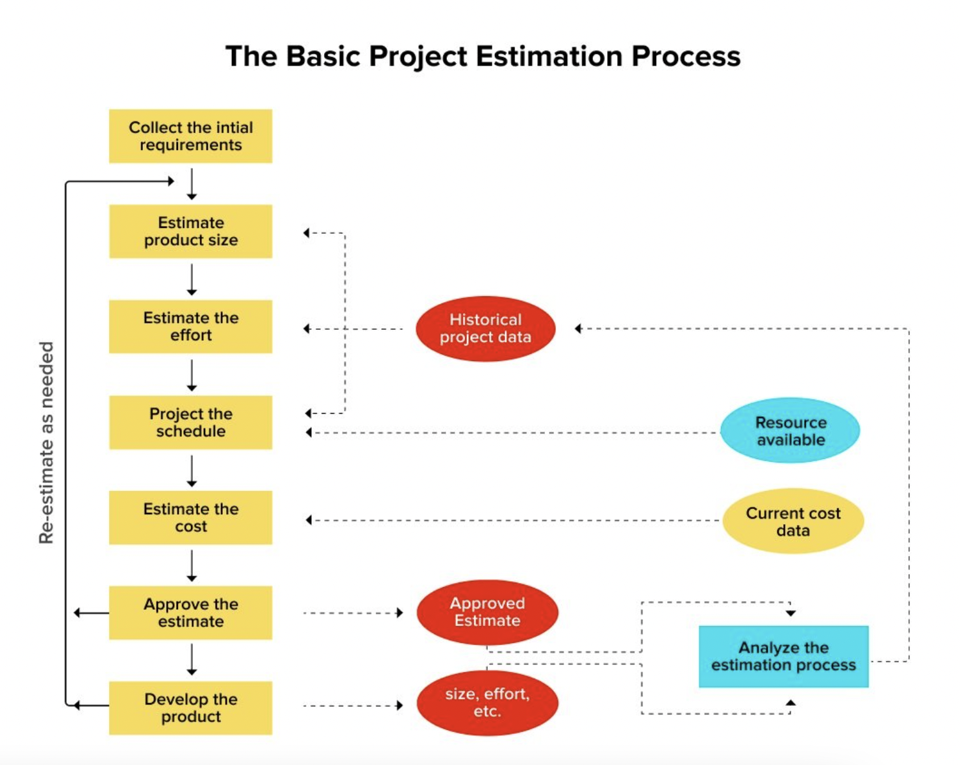

This is an exercise that typically takes two to four weeks, depending upon the project’s complexity.

The process includes:

1. Conduct Stakeholder Interviews
2. Define High-Level Product Backlog
3. Understand the Client and its Potential Customers
4. Prioritize Requirements
5. Prepare the Minimum Viable Product (MVP) Backlog
6. Estimate the Project Cost and Timeline

### Story Points

Traditional software development teams provide estimates in days, weeks, and months. Many agile teams, on the other hand, have transitioned to story points. Story points are a unit of measure for estimating the total effort required to fully implement a product backlog item or any other piece of work. Teams assign story points based on the complexity of the task, the amount of work, and the risk or uncertainty involved. Values are assigned to help break down tasks into smaller chunks and address uncertainty more effectively. This helps teams understand how much they can do in a given amount of time, as well as build consensus and commitment to the solution over time.

A few reasons to use story points are:

* Non-project work that inevitably slips into our days: emails, meetings, and interviews that a team member may be involved in are not taken into consideration by dates.
* Dates have a strong emotional component. Emotional attachment is eliminated by relative estimation.
* Each team will estimate work on a slightly different scale, resulting in naturally varying velocity (measured in points). As a result, using velocity as a political weapon is no longer possible.
* You can quickly assign points without much dispute once you've agreed on the relative effort of each story point value.
* Story points are awarded to team members for solving tasks that are challenging rather than time consumption. This helps the team focus on providing value rather than spending time.

### What are the Best Methods for Estimation of Software Projects?

In the Agile development journey, estimation plays a vital role in making progress. Here are some of the most popular Agile estimation techniques in use:

**1. Planning Poker**

Number-coded playing cards are used to estimate an item. The cards are distributed across the team (sized 2-10), with each of the cards representing a valid estimate.

The reading on the cards could be something such as — 0, 1, 2, 3, 5, 8, 13, 20, 40, and 100. Now, the product owner or the analyst describes the user story to the team, and the team can ask any related queries.

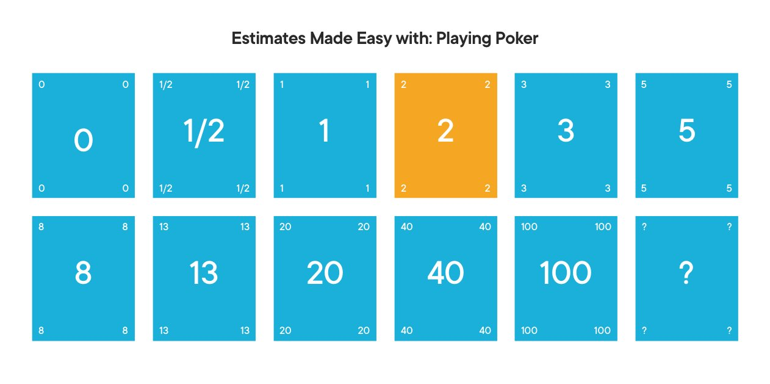

Each team member secretly selects a card number for an estimate, which is revealed when all the cards are turned over. The card with the most voting is the finalized estimate for the item under discussion. In case of uneven estimates, meetings are held, and the next round of voting commences to come up with an estimate everyone agrees with.

Planning Poker use cases:

There are a small number of items

Establishing mutual understanding among team members

Running late-stage estimations

The backlogs are highly prioritized

**3. T-Shirt Size Estimation**

In this t-shirt sizing Agile estimation technique, the items are estimated in standard t-shirt sizes (i.e., XS, S, M, L, and XL). This is more of an informal but creative technique, and numbers can be assigned to each user story categorized under different t-shirt sizes for better understanding.

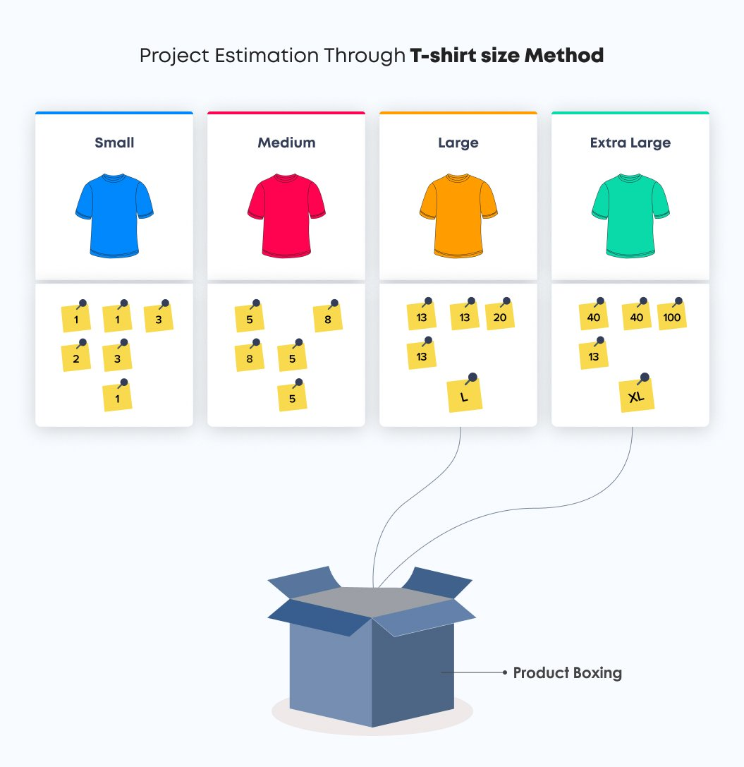

A story estimated as XS is usually small and requires less effort than the XL story, which is large and has a big estimation number.

T-Shirt size estimation use cases:

Running rough estimations

The team is new to Agile estimation

There are large backlogs

Running early-stage estimations

**5. Affinity Mapping**

The affinity estimation technique in Agile can be applied when there are fewer backlog items and a small team size. Affinity mapping involves the following steps:

a) Silent Relative Sizing

In this step, two cards are placed on a wall or a board in opposite corners (one is named Smaller and the other Larger). Next, all the participants receive a subset item from the product owner and are asked to size each item individually.

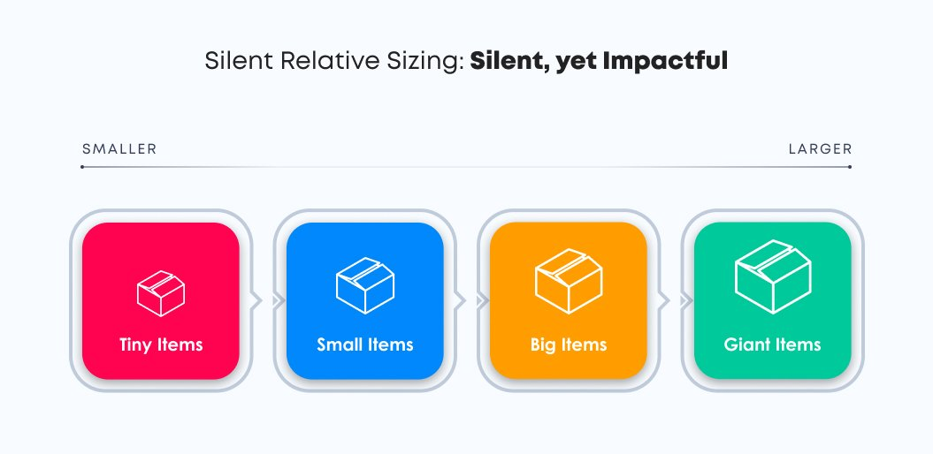

Here, participants can ask the product owner clarifying questions. In case of complicated product backlog items, they are taken off the fold and placed separately. This drill consumes five to twenty minutes.

b) Editing the Wall

In step 2, items can be moved from one location to another based on team members’ discretion. Team members can also discuss the design and implementation aspect, given the allotted period of twenty to sixty minutes. In the case of minimal discussion, the team members can close the activity.

c) Placement of Items in Correct Locations

In this step, team members place the items in suitable positions, post discussions. Here, the t-shirt Agile sizing technique, Fibonacci series, etc., can be used to estimate the relative item size.

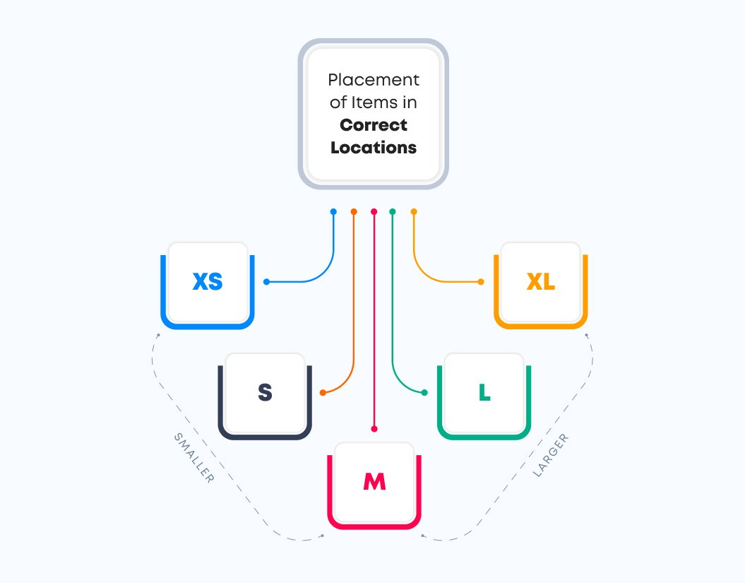

d) Product Owner’s Prerogative

In a case where the product owner observes a discrepancy in the estimations or wishes to discuss more features and requirements of an item with the team members, they should address these topics prior to making the final estimations.

e) Export to Project Backlog Management Tool

In this final step, the product owner can save the finalized estimations by exporting them to a product backlog management tool.

Affinity Mapping use cases:

Estimating a long-term plan for a project

Gaining mutual understanding in the team

There are large backlogs to handle

Running early-stage estimations

**8. Fibonacci Sequence for Story Point Estimation**

Fibonacci sequence is a popular scoring scale within some teams. This sequence is the sum of the previous two numbers in the series- 0, 1, 1, 2, 3, 5, 8, 13, 21, 34, 55, 89… and continued whereas the linear sequence is- (1, 2, 3, 4, 5, 6, 7, etc.).

This comes with its benefits. While looking at a story and determining whether it’s a 5, 8, or 13, it’s quicker and easier to land with an answer than trying to come up with the correct number between, say, 4-15. The team is likely to reach a consensus much more quickly.

The team will have to discuss the work and choose the best estimate from a limited set of options.

The options, however, can still be limited. For example, a story could be estimated as more effort than 34 but less than 55. In instances like these, this scale has chances of being less accurate.

Fibonacci Sequence use cases:

When estimating for large and complex tasks

If the need is to prevent estimates from getting too close to each other

Are concerned about the estimate accuracy

### Steps to Successful Story Point Estimation in Agile

The story points approach in the Agile estimation technique uses historical data to compare features of previous, similar projects to generate a precise estimate.

The steps involved in the estimation method with story points are as follows:

* Identify user stories
* Discuss the requirements of the user story. It is the responsibility of the Product Owner or business analyst to answer the questions and explain what precisely the referred story entails
* Create a matrix for estimation: The estimation matrix is a numeric scale that is used to evaluate the selected pieces of work. This scale can be the Fibonacci sequence (…5, 8, 13, 21, 34 …) or the straightforward linear scale (… 3, 4, 5, 6, 7 …).  
  Many teams prefer the Fibonacci scale because the gaps between numbers in this series are more extensive than in the linear scale. This simplifies visualizing the difference between the values assigned to the separate tasks.
* Choose an Agile estimation technique
* Conduct sprint planning
* Validate that the estimates are internally consistent and align with the stories as the process goes along

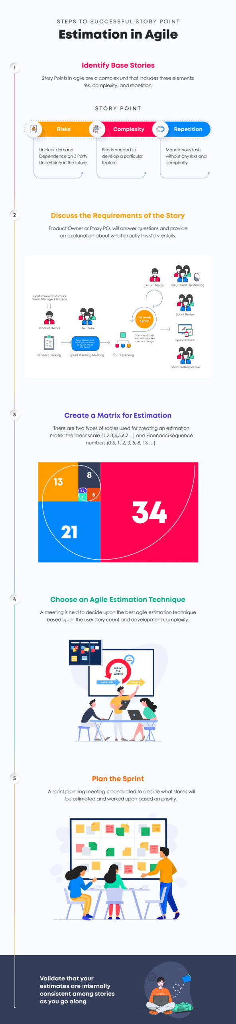

### What is Sprint Velocity?

Sprint velocity measures an individual team’s rate of work during an average sprint.

### How to Estimate Sprint Velocity

Sprint velocity is the number of story points that can be completed during a sprint by a specific team. Unfortunately, there is not a concrete way to determine sprint velocity until the first sprint has been finished.

However, the future velocity can be predicted by analyzing the team’s historical data (i.e., keeping track of how many story points were completed in a previous sprint). The total number of completed story points and measuring the team’s actual velocity during a sprint can be used as a reasonable data count. This will help to determine how many sprint cycles will be required to complete the project.

## Summary

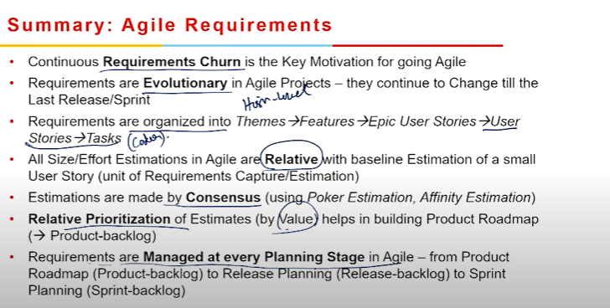

# Module 6

## Release Planning in Agile

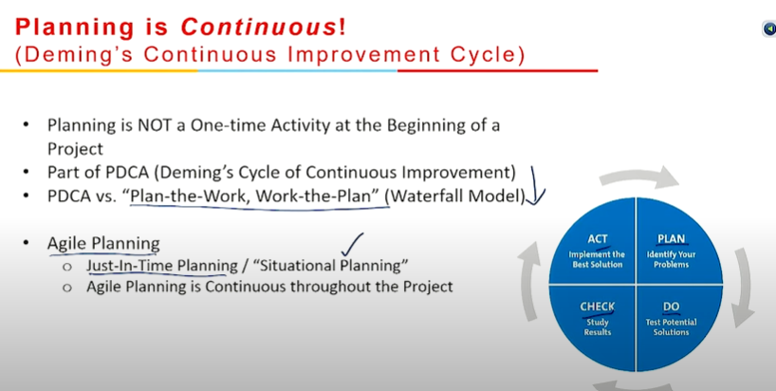





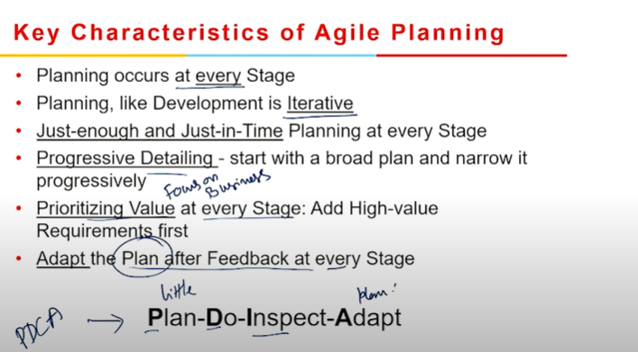

### Characteristics of Agile Planning

1. **Agile development releases and fixed-length iterations**  
    Releases and iterations are the two main delivery units in agile software development methods. A release is made up of multiple iterations, each of which is its micro-project. Features, defects, enhancement requests, and other work items are organized, prioritized, and assigned to a release. These work items are then prioritized and assigned to iterations within a release. The result of each iteration is working, tested, accepted software, and associated work items.
2. Agile development delivers working, tested software  
     
    The fundamental metric of progress for an agile development team is the delivery of working, tested features. Working features enable and improve team collaboration, customer input, and overall project visibility. They prove that the system and the project are on track.
3. Value-driven development  
     
    Agile development methods place a strong emphasis on providing business value quickly and consistently, as measured by running, tested software. This requires the team to focus on product features as the core planning, tracking, and delivery unit. The team keeps track of how many running, tested features they deliver from week to week and iteration to iteration.
4. Continuous planning  
     
    Planning must continue throughout the project, according to agile methodologies. Nobody on an agile project will take it for granted that the plan is workable until it can demonstrate its accuracy regularly.
5. Multi-level planning in agile development  
     
    Continuous planning is much more accurate if it occurs on at least two levels:  
   * At the release level, we define and prioritize the features that we must have, would like to have, and can live without by the deadline.
   * At the iteration level, we pick and plan for the next batch of features to implement, in priority order. If features are too large to be estimated or delivered within a single iteration, we break them even further.
6. Relative estimation  
     
    To speed up planning and eliminate unnecessary complexity, many agile development teams utilize relative estimation for features. Instead of estimating features across a spectrum of unit lengths, they select a few (three to five) relative estimation categories, or buckets, and estimate all features in terms of these categories.
7. Emergent feature discovery  
     
    Agile development projects prioritize and estimate items quickly, then refine details as necessary, instead of spending weeks or months detailing requirements before beginning development. Customers, testers, and developers collaborate to describe the features of an iteration in better detail. Additional features can be identified, but no feature is described in detail until it is prioritized for an iteration.
8. Continuous testing  
     
    We can deterministically measure progress and prevent defects using continuous testing. We crank out features that are up and running and have been thoroughly tested. This significantly lowers the chances of project failure in further stages.
9. Continuous improvement  
     
    Both the system and the project are being refined on a regular basis. We can alter our estimations and plans by reflecting on what we've done using concrete metrics like running, tested features, and more subjective measures. However, we also use the same method to continuously refine and improve the process itself.
10. Small, cross-functional teams  
      
     Smaller agile development teams have been proven to be far more productive than larger teams, with the ideal number of people ranging between five and ten. If you need to scale a project to include more people, try and keep individual teams as small as possible and coordinate efforts across teams. Scrum-based organizations of up to 800 employees are using a "scrum of scrums" method to project planning and coordination with great success.

## Agile Release Planning













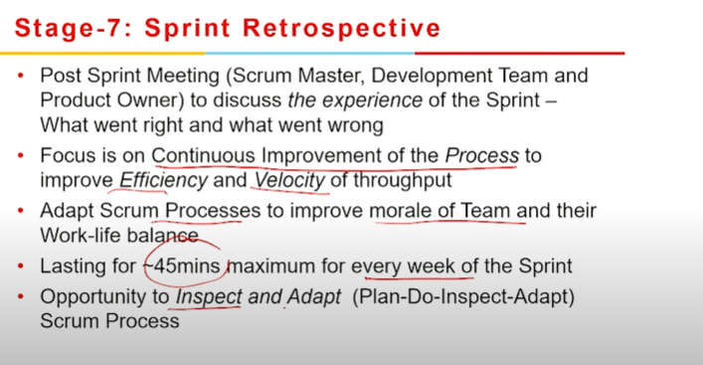



### Agile Release Planning

Agile release planning is a product management technique that involves planning incremental product releases. It is not the same as traditional software planning, which focuses on major releases.

When planning an Agile release, you prepare for staged releases and then break them down into several sprints or iterations.

Depending on the size of the project and the structure of your team, you may have several sprints running at the same time.

A sprint may end with a new product increment, although this does not always imply a product release.

Imagine writing a book: each sprint should end in a new draft. However, just because you have a finished draft for your client to review does not imply you need to make it available to the general public.

Release planning helps in planning which product increments and when they will be released to the market.

This approach helps your team in adapting to the unpredictability of software development.

It's also an essential part of the Agile Software Development Life Cycle.

### What is Agile release planning?

Agile release planning is a product management method where you plan incremental releases of a product. It differs from traditional software planning where you focus on major releases.

In Agile release planning, you prepare for staged releases and then break those down into several different sprints or iterations. Depending on your team structure and the size of the project, you may even have several sprints running at the same time.

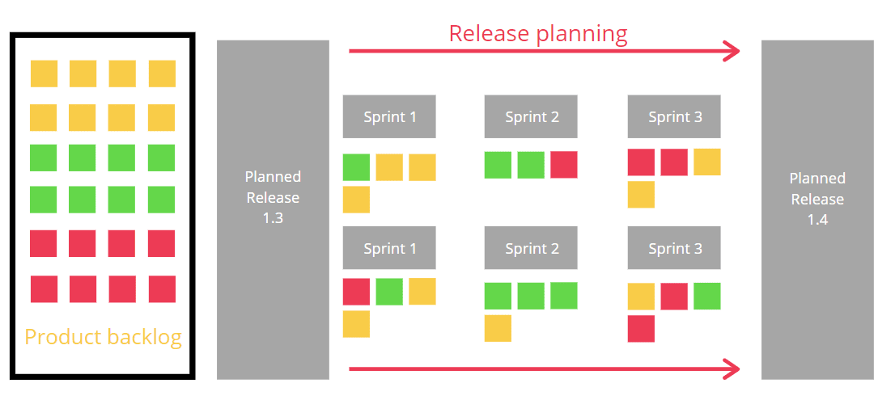

A sprint ends with a new product increment, but that may not mean a product release happens. Think about writing a book — each sprint should end with a new draft. But, just because you have a finished draft for your client (editor, publisher, etc.) to review doesn’t mean you release it to the public.

You might create versions 1.1, 1.12, 1.14, 1.2, and so on, each one incorporating the new features and improvements of the last. But you’ll only release the big ones (1.1 and 1.2, etc.)

Using a release plan helps you plan which product increments (versions) get released to the market and when. And it’s an integral part of the [Agile SDLC](https://monday.com/blog/project-management/agile-sdlc/) (Software Development Life Cycle) because it can also give higher-ups peace of mind that there’s a structure and plan beyond just the next sprint, and helps the individual Agile teams stay on track.

### Purpose of Agile release planning

The purpose of release planning is to ensure that the product is always moving in the right direction and that logical releases are happening regularly. A release plan outlines upcoming releases soon but does not attempt to plan for the long term.

It's more detailed than a product roadmap. However, an Agile release plan does not outline the work that will be completed in each release. Instead, it groups iterations or sprints into releases.

Traditional executives are concerned that adopting Agile will result in each release being a random collection of features. A release strategy ensures that you always create a coherent version of your product.

It's an excellent tool for combining changes that will significantly improve the user experience.

### Steps to implement Agile release planning

1. Evaluate your product's vision and roadmap, focusing on specific outcomes.
2. Based on these results, expand and prioritize your product backlog.
3. Set a clear release target that incorporates all of the logical product backlog items.
4. Break your releases into several sprints or iterations.

## Summary

